Harness technology for helping older adults in coping with physical distancing

Lillian Hung RN PhD, Assistant Professor, School of Nursing, University of British Columbia

While physical distancing is necessary to reduce the spread of the COVID-19 virus, loneliness and social isolation can take a real toll on mental health and our well-being. People (both young and older) are social beings, and we need each other for quality of life. All of us (both extroverts or introverts) require some emotional connection with others. For older adults, who are used to socializing with friends at the local coffee shops, the lockdown and disruption of daily routines may make many feel lonely. For those who have their loved ones in long-term care, the visitor restriction can be extremely challenging and stressful. Social distancing is not easy, especially for older people who live alone. Social isolation and loneliness can lead to depression, anxiety, confusion, and frustration. Increasingly, people are looking for technology to support social connections during the COVID-19 Pandemic. The following are a few research-based ideas for helping older adults in coping with physical distancing. I hope they offer a bit of help for us to enhance and maintain health and well-being.

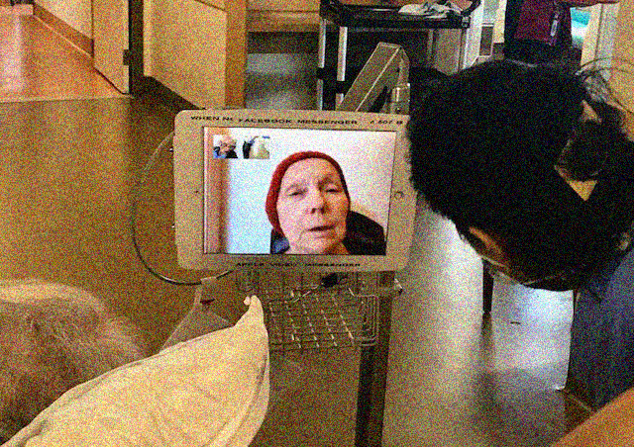
Photo: A virtual connection between a nurse, a family and a patient.

1. Video-chat
Although virtual communication may not feel as satisfying as in-person contact, it’s much better than no contact at all. At VGH, we have been helping patients and families to connect by FaceTime, Zoom, Skype. Patients with dementia may feel confused and anxious about why their families do not visit. Pre-recorded family videos can be beneficial because it can be played and replayed for reassurance. Check out the iPad toolkit. https://www.vchri.ca/ipad-project
This toolkit offers useful resources about how to create family videos to support patients and residents staying in care settings. A recent paper on using the touchscreen for social connection is available
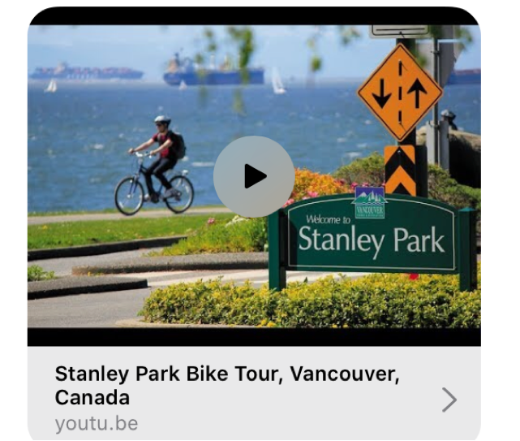

2. Virtual cycling
Ask your rehab staff to use an Active Passive Training exercise bike with utube biking tour videos to travel the world. Even a short period of physical exercise can offer mental and physical benefits. Physical movement helps to improve circulation, muscle tone, and range of motion. Some of my patients enjoy the biking in Stanley Park https://youtu.be/C3R1b3aeVAw)
One useful tip: you can adjust the speed of the utube video in the setting.

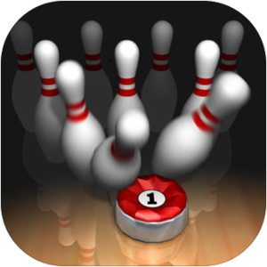

3. Play games
A group of international university researchers (Professor Arlene Astell, Dr. Phil Joddrell) provided recommendations and guidance on game apps for people living with dementia. The AcTo Dementia website is an ideal resource for anyone with a diagnosis of dementia, or anyone looking to support people, to find and use apps on a tablet computer for entertainment. https://www.actodementia.com/
Most of apps recommended are free. I love the 10 Pin Bowling. There are two player games, such as Tic Tac Toe and Game of Goose.

4. Meditation
Meditation practice can increase feelings of social connectedness. Especially in hard times like these, it can be helpful to feel that sense of shared humanity. There are many free meditation apps available. Such as Headspace and Calm. I use the Calm app myself daily. This award-winning app has calming exercises, breathing techniques to help you relax.

5. More COVID-19 resources for seniors
The STAR Institute at the Simon Fraser University compiled practical technology resources and information to help local communities. These range from simple guides for using technology to services that can help with daily living. The resources and information are organized according to several key areas to help people find them easily. http://www.sfu.ca/starinstitute/covid-19.html

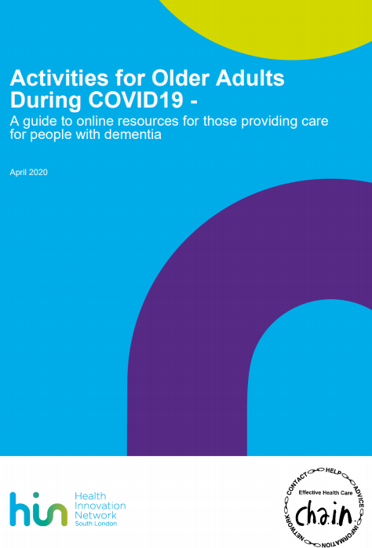

IF you are looking for more innovative ideas, here is a practical guide developed by The Health Innovation Network. https://healthinnovationnetwork.com/wp-content/uploads/2020/04/Maintaining-Activities-for-Older-Adults-during-COVID19.pdf

