Sponsorship opportunities are available for the West Coast Conference on Aging at the Pan Pacific Hotel (Downtown) Vancouver
May 31 – Jun 1, 2024

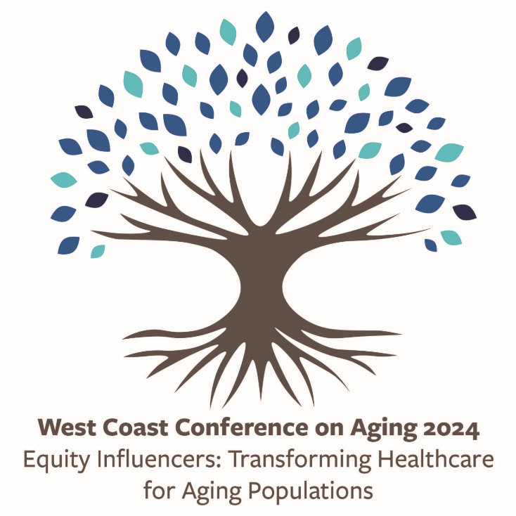
Your support will provide exceptional brand visibility, networking opportunities, and the chance to showcase your commitment to the 2024 West Coast Conference on Aging, a visionary event poised to redefine the future of seniors’ care.
This dynamic two-day experience brings together some of the most innovative people in healthcare–leaders, clinicians, change makers, people with lived and living experience, and policymakers—in a powerful exchange of ideas and solutions. These are the people not just part of the conversation, but the ones actively reshaping it.
This conference isn’t just an event, it is a catalyst for meaningful change. With a deep commitment to understanding and addressing inequities in the aging experience, participants will engage in conversations that challenge norms towards a fairer, more responsive future in seniors' wellness and healthcare. Together, we will introduce fresh perspectives and forge a path toward a more equitable future in aging care.
Gold Sponsorship $5,000
Gold sponsors are recognized as direct supporters for keynote speakers and networking events. Gold sponsorship includes:
- One complimentary registration with access to all events (e.g., all sessions, meals, etc.)
- Verbal acknowledgement of sponsorship at the podium for the event
- One space in the lobby with a table that can be used for display
- Acknowledgement of Gold Sponsorship and inclusion of logo within written event program and on the conference website
Four (4) Sponsorships Available
- Friday Opening Keynote Presentation
- Networking Event and Poster Presentations
- Saturday Opening Keynote Presentation
- Saturday Closing Keynote Presentation
Silver Sponsorship $2,500
Silver sponsors are recognized as direct supporters for the refreshment/dining experiences. Silver sponsorship includes:
- One complimentary registration with access to all events (e.g., all sessions, meals, etc.)
- Printed sponsorship recognition at the event as a Silver Sponsor
- Acknowledgement of event sponsorship and inclusion of logo within the written event program and on the conference website
Four (4) Sponsorships Available
- Friday Morning Refreshment Break Sponsor
- Friday Lunch Sponsor
- Saturday Morning Refreshment Break
- Saturday Lunch Sponsor
Supporting Sponsorship $1,000
Supporting sponsors are recognized for their overall contribution and support of the event and includes:
- Acknowledgement of event sponsorship and inclusion of logo within the written event program and on the conference website
Sponsorship Agreement
Company Name: | Click or tap here to enter text.
 | (As it should appear in all print)
Contact Name | Click or tap here to enter text.
Full Address | Click or tap here to enter text.
Phone Number: | Click or tap here to enter text.
Email Address: | Click or tap here to enter text.

Requested Sponsorship Item:
Gold Sponsorships (please indicate top 2 preferred events)
Please return completed form to: conferences@providencehealth.bc.ca

Cheques payable to:
Providence Health Care
Mail:
West Coast Conference on Aging 2024, c/o Perminder Sihota
4865 Heather Street
Vancouver, BC, V5Z 0B3

☐ Friday Opening Keynote Presentation
☐ Networking Event and Poster Presentations
☐ Saturday Opening Keynote Presentation
☐ Saturday Closing Keynote Presentation
Silver Sponsorships (please indicate top 2 preferred events)
☐ Friday Morning Refreshment Break
☐ Friday Lunch Sponsor
☐ Saturday Morning Refreshment Break
☐ Saturday Lunch Sponsor
Supporting Sponsorships
☐ Supporting sponsor

